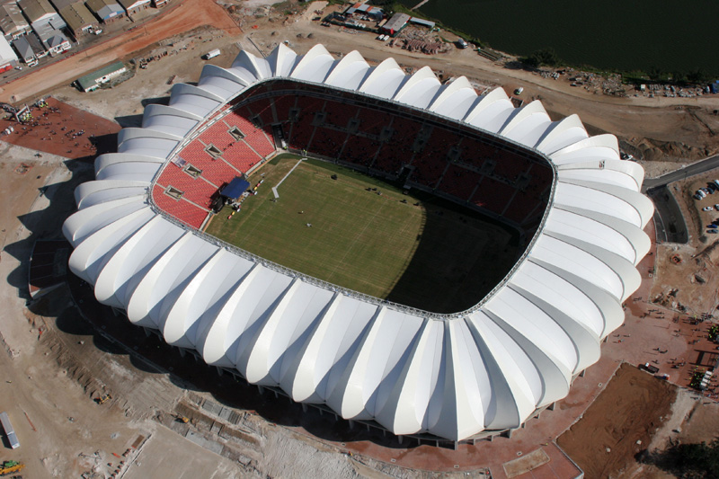 | 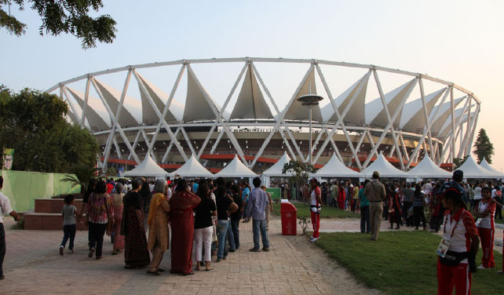 | 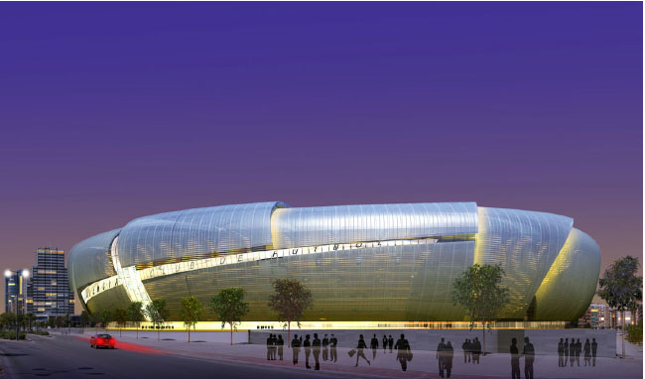 | 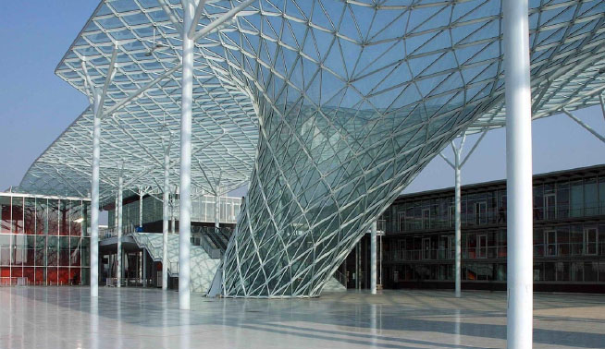

Public Lecture – “Lightweight Structures”

Professor Mike Schlaich
Sydney, Thursday October 13 2011
Cost $60 pp – Free for Bona fide students of engineering or architecture
Pre-registration essential – see form below
Check in during afternoon tea: 15.15 with the Lecture: 16.15 – 17.30

Venue - Novotel Hotel - Sydney Olympic Park

This is a unique opportunity to listen to one of the most renown designers of innovative lightweight structures in the world. His work covers major sporting stadia, freeform glazed roofing for transport hubs and major hotels along with breath taking cable supported and curved footbridges and highway bridges.
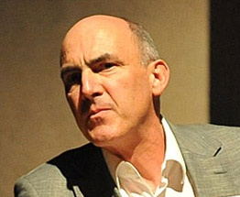 | Mike is Professor for Structural Engineering chairing the Department of Conceptual and Structural Design at Technische Universität Berlin (TU Berlin). He is also the Managing Director of Schlaich Bergermann und Partner, Consulting Structural Engineers, Germany.  Mike worked in Spain as a structural engineer before joining in the firm of Schlaich Bergermann and Partner in Stuttgart which specializes in lightweight and long-span structures. He became Managing Director of the firm in 2002, which has been active in the field of renewable energies for more than 20 years.

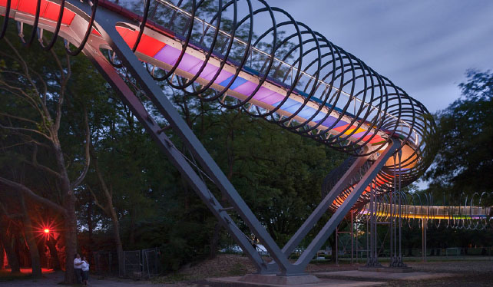 | 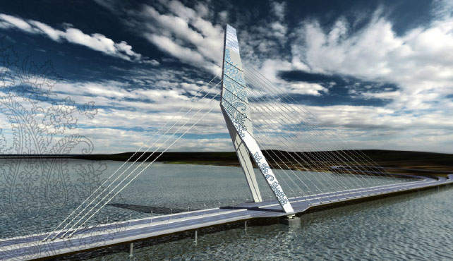 | 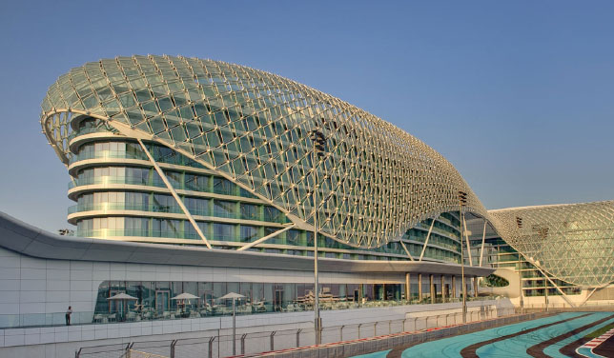

Sample Structures by Schlaich Bergermann and Partners

Pre-registration required

Cost: $60 per person – Correct CASH only at door, no credit card facility.
Free for Bona fide Students of Engineering and Architecture with valid student ID
Email Registration Details to registration@LSAA.org
- Your name
- Your company name For students, please list School/Course and University
- Your email address
- Mobile phone number
- Please put LSAA Public Lecture in the subject of your email
The Novotel is located directly opposite the Homebush Bay Olympic Park train station and adequate parking is available in several nearby parking stations.

Other LSAA Events – Supported by Engineers Australia
The Public Lecture is part of the LSAA2011 Conference “Collaborative Design of Lightweight Structures” but the public is able to attend this special lecture. If you are not attending the Conference you must register.
It counts towards Engineers Australia CPD requirements.
More details of the Conference including program and registration details are on the website www.LSAA.org
A Pre-conference Technical Workshop dealing with the Design of Tensioned Fabric Shade Structures is also being held on the Wednesday October 12 2011 and our Design Awards are being held during the Conference Dinner following the Public Lecture.
Limited spaces are currently available for all these events. Bona fide students may register for each day event at $50 pp per day until spaces are filled. Please email registration@LSAA.org to check availability. The Design Awards Dinner costs $175 pp (no discount for students)

